2. PROPERTIES OF FLUIDS
MASS DENSITY/ SPECIFIC MASS$\left(ρ\right)$: Mass of substance per unit volume at given condition.$ρ({kg}/{m^{3}})=m/V$
$$ρ_{water}=1000 {kg}/{m^{3}}$$ |  |  | $$ρ_{kerosene}=810 {kg}/{m^{3}}$$ | $$ρ_{mercury}=13600{kg}/{m^{3}}$$
FACTOR | $$FACTOR⇑$$ | Remarks
T | $ρ$ $⇓$ | Except Water form $0° C to 4°C \& T_{stp}=4°C for water and 20°C for Gas$
P | $ρ$ $⇑$ | $$P_{stp}=1 atm=101.325 KPa$$
Height | $$ρ=constant$$
SPECIFIC WEIGHT ($γ or ω or ρ_{g}$)/ WEIGHT DENSITY: Weight per unit volume. $γ (N/{m^{3}})=ρg$
FACTOR | $$FACTOR⇑$$ | Remarks
$$g$$ | $γ$ $⇑$ | At polls, $γ$ is higher & $g_{moon}={g_{earth}}/6$

SPECIFIC/ RELATIVE GRAVITY ($S_{g}$) | SPECIFIC VOLUME $\left(v\right)$
It’s ratio of density of fluid to the standard fluid. | It’s reciprocal of mass density.
$$S_{g}(Unitless)={ ρ_{fluid}}/{ρ_{water}}={ γ_{fluid}}/{γ_{water}}$$ | $$v({m^{3}}/{kg})=1/ρ$$
PRESSURE: Compressive force per unit area. It’s scalar function.
$$P_{abs} or P_{total}(+ve)$$ | $$P_{local}(+ve)$$ | $$P_{gage}(+ve or-ve)$$
BULK MODULUS ($K$) AND COMPRESSIBILITY$(β)$:
$$K\left(in Pa\right)=\frac{Change in pressure}{Volumetric Strain}=\frac{∆P}{{dV}/V}=\frac{-P}{ε_{V}}=\frac{P}{{dρ}/ρ}$$ |  |  | $$β (in {Pa}^{-1})=\frac{1}{K}$$ | $$K is more⇒difficult to$$  $$compress⇒β decreases$$
At $20°C$ & $1 atm$ | $$K_{air}=1.013*{10}^{5} Pa$$ | $$K_{water}=2.06*{10}^{9} Pa$$ |  | $$K_{steel}=2.06*{10}^{11} Pa$$
Compressibility are considered in hammering effect.
PRESSURE WAVE VELOCITY IN FLUIDS:
$$C=\sqrt{K/ρ}$$ | $C=$ Pressure Wave Velocity = Velocity of Sound
In isothermal conditions, $K=P=ρRT$  $$C=\sqrt{RT}$$ | In adiabatic conditions, $K=\left({C_{P}}/{C_{V}}\right)P$  $$C=\sqrt{\left({C_{P}}/{C_{V}}\right)RT}$$

MECH NUMBER ($M_{a}$) |  | $$M_{a}=\frac{V}{C}$$ |  |  |  | $V=$ Velocity of Fluid or body  $C=$ Sound/ Sonic Velocity
Incompressible | Subsonic |  | Transonic | Sonic | Supersonic |  | Hypersonic
$$<0.3$$ | $$<1$$ |  | $$≈1(0.8<M_{a}<1.2)$$ | $$1$$ | $$1<M_{a}<3$$ |  | $$M_{a}>3$$

DYNAMIC VISCOSITY ($μ$): The viscosity of a fluid is a measure of its resistance to deformation at a given rate. |  |  |  | 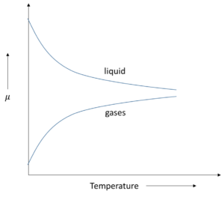
Unit | SI System: $Pa-s or {kg}/{\left(m s\right)}$  CGS System: $Poise or {gm}/{\left(cm s\right)}$ |  | $$1 Pa-s =10 Poise$$
$$μ_{gas}=\frac{aT^{1/2}}{1+\frac{b}{T}}∝\sqrt{T}$$ |  | $$μ_{liquid}=a\left[{10}^{b/{\left(T-C\right)}}\right]$$
Viscosity is caused by intermolecular forces of cohesion and due to transfer of molecular momentum between fluid layer of which in liquids the former and in gases the layer contributes the major part towards viscosity.

NEWTON’S LAW OF VISCOSITY: It’s valid for two parallel plate,  $$τ=μ\frac{du}{dy}, Where u=f(y)$$  Condition for linear profile: 1) Gap ($y$) is smaller, 2) ${dP}/{dx}=0$  ASSUMPTIONS IN NEWTONS LAW OF VISCOSITY:  - Fluid particles move in such a direction maintaining straight and parallel lines  - No slip condition at surface & other fluid particles slid over each other retarded the motion because of interaction between faster and slower moving fluid.  - $τ∝{du}/{dy}, {du}/{dy}=$ Slope or rate of shear strain or distance rate of velocity diff. | 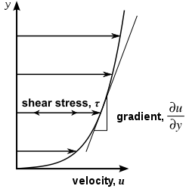
NON-NEWTONIAN FLUIDS (RHEOLOGY):
NON-NEWTONIAN FLUIDS | NEWTONIAN FLUIDS
$$μ=Slope=Constant (Linear Relationship)$$ | $$μ=Slope≠Constant(Non-Linear Relationship)$$

POWER LAW:  $$τ=τ_{y}+A{\left(\frac{du}{dy}\right)}^{n}$$ | $τ_{y}=$ Minimum Yield Stress to start Deformation,  $A=$ Multiplying factor,  $n=$ Power Index,

TYPES OF NON-NEWTONIAN FLUIDS
TIME INDEPENDENT | TIME DEPENDENT
Pseudoplastic/ Shear Thinning:$τ_{y}=0, n<1$  $$μ_{app}= A{\left(\frac{du}{dy}\right)}^{n-1}$$ E.g. Blood, Milk, Paper Pulp, etc… | Thixotropic:$τ_{y}>0, n<1$  E.g. Printer’s ink, leaps sticks, Etc…
Dilatant/ Shear Thickening:$τ_{y}=0, n>1$  $$μ_{app}= A{\left(\frac{du}{dy}\right)}^{n-1}$$ E.g. Starch, Sand, etc… | Rheopectic:$τ_{y}>0, n>1$  E.g. Gypsum, Etc…  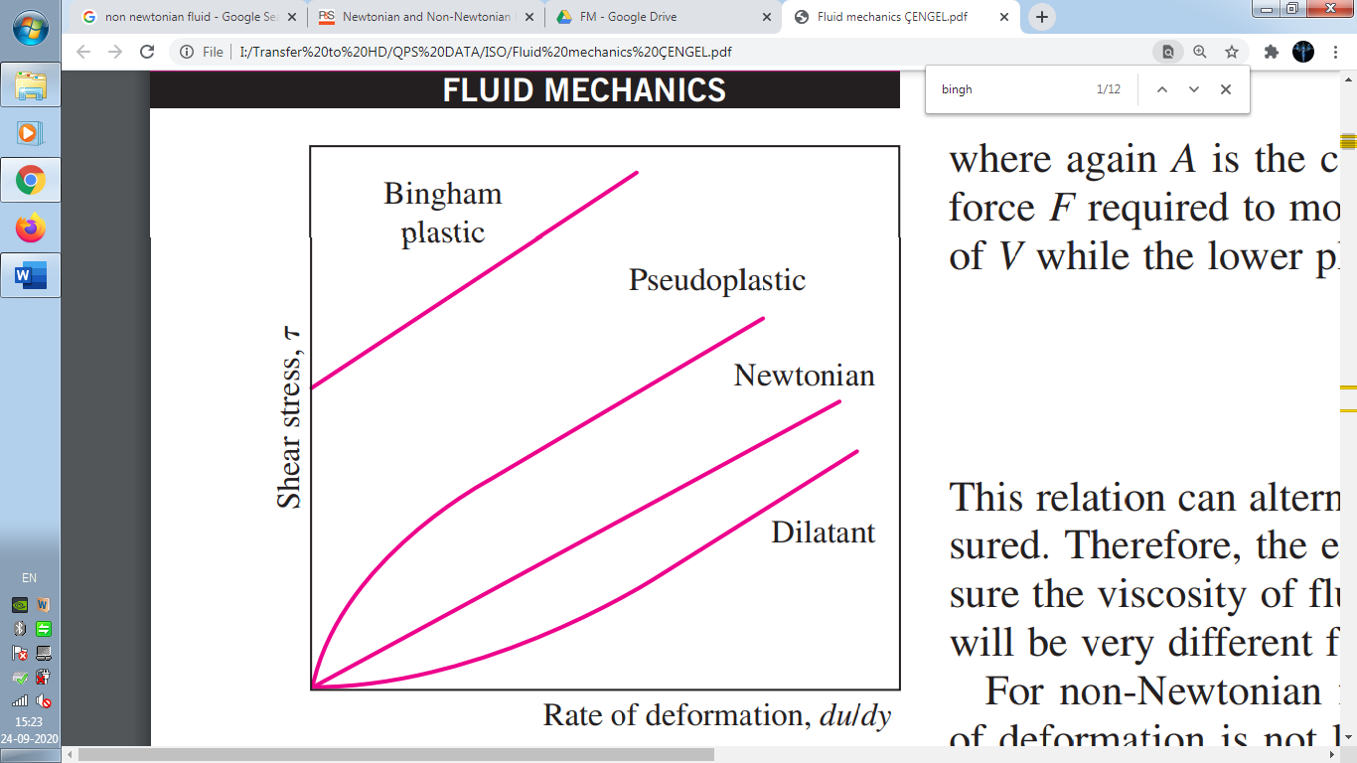
Bingham Plastic:$τ_{y}>0, n=1$
$$μ_{app}= A$$ | E.g. Toothpaste (Dual Behaviour), etc…

Newtonian Fluid: $τ_{y}=0, n=1$
Ideal Fluids: $τ_{y}=0, n=1,A=0$
Solids: ${du}/{dy}=0$ 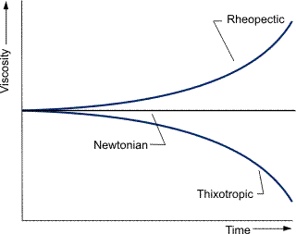
VISCOELASTIC FLUIDS: Fluids can regain their shape (Partially) are called viscoelastic fluids.
E.g. Biological Fluids, Mixture of Liquids and solid partials
IDEAL FLUIDS OR PREFECT FLUID | REAL OR PRACTICAL FLUIDS
- Non-Viscous (Frictionless)/ Inviscid  - Incompressible ($K=∞ \& β=0$)  - No surface tensions  - Doesn’t exist in reality  - Doesn’t offer shear resistance when fluid is in motion  - Velocity distribution in motion is rectangular or uniform at a cross section | - Viscous (Friction)  - Compressible  - Surface Tension

$$KINEMATIC VISCOSITY ϑ(in Stokes or {m^{2}}/s)=\frac{μ}{ρ}$$ |  |  | $$1 Stokes=1{cm^{2}}/s$$
At $20°C$ & $1 atm$ | $$ϑ_{water}=1*{10}^{-6} {m^{2}}/s$$ |  | $$μ_{water}=1.005*{10}^{-3} Pa s$$
 | $$ϑ_{air}=15*{10}^{-6} {m^{2}}/s≈15*ϑ_{water}$$ |  | $$μ_{air}=1.81*{10}^{-5} Pa s$$
$$μ_{water}=\left(50 to 55\right)μ_{air}@ 20°C=\left(100\right)μ_{air}@ 0°C$$
EFFECT OF TEMPERATURE ON $ϑ$ |  | $$ϑ∝T^{3/2}$$

$$SURFACE TENSION σ_{s}\left(J/{m^{2}} or N m^{-1}\right)=\frac{Force}{Surface Length}=\frac{F}{2b}=\frac{Surface Energy}{Area Change}=\frac{ σ_{s} \left(2bx\right)}{\left(2bx\right)}$$
FACTORS AFFECTING SURFACE TENSION:  - $Cohesion↑ ⇒σ_{s}↑$  - $Temperature↑ ⇒Cohesion↓ ⇒σ_{s}↓$  - Pressure effect is negligible  - $Impurity↑ ⇒σ_{s}↓$  - Beyond Critical Point there is no surface tension | Surface Tension of Some Fluid in Air At 1atm  Fluid $$σ_{s}(N m^{-1})$$  Water at $0°C$ 0.076  Water at $20°C$ 0.073  Water at $100°C$ 0.059  Soap Solution at $20°C$ 0.025  Mercury at $20°C$ 0.440
EXCESSIVE HYDROSTATIC PRESSURE OR GAGE PRESSURE INSIDE A DROPLET/ BUBBLE:
$$Pressure force=Surface tension$$
CASE-I (EXCESS PRESSURE IN LIQUID JET): $∆P\left(LD\right)=σ_{s}(2L)$
CASE-II (LIQUID DROP):$∆P πR^{2}=σ_{s}(2πR)$
CASE-III (EXCESS PRESSURE IN SOAP BUBBLE):$∆P πR^{2}=σ_{s}(2*2πR)$

ANGLE OF CONTACT ($θ$): Tangent between the solid towards liquid make angle with vertical surface.  For Wetting fluid, For Non-Wetting fluid,  $$Water, θ<90°$$ $$Mercury, θ>90°$$  Cohesion < Adhesion Cohesion > Adhesion  Capillary rise Capillary fall  FACTORS AFFECTING $θ$: 1) Liquid, 2) Solid, 3) Impurities | 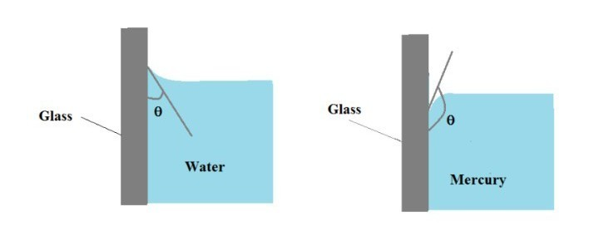
CAPILLARITY: It’s ability to rise or fall liquids in tubes of small diameter.  $$Surface Tension=Weight of Vol. of water⇒σ_{s}\cos{θ}\left(2πR\right)=πR^{2}h γ$$  $$h=\frac{2 σ_{s}\cos{θ}}{γR}, Where γ=ρg$$  Obtuse angle: $θ>90°$ Acute angle: $θ<90°$  CAPILLARITY THROUGH PARALLEL PLATES:  $$Surface Tension=Weight of Vol. of water⇒σ_{s}\cos{θ}\left(2L\right)=Lth γ$$  $$h=\frac{2 σ_{s}\cos{θ}}{γt}$$  CAPILLARITY THROUGH ANNULAR TUBES CAPILLARITY THROUGH DIFFERENT FLUIDS  $$h=\frac{2 σ_{s}\cos{θ}}{γ(R_{o}-R_{i})}$$ $$h=\frac{2 σ_{s}\cos{θ}}{γR(S_{1}-S_{2})}$$ |  | 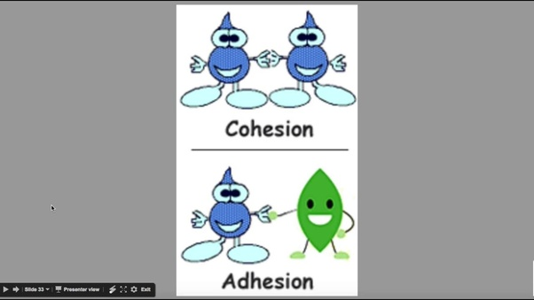
PRACTICAL EXAMPLES OF CAPILLARITY:

- Rise of oil in a cotton wick
- Rise of sap in trees
- Blotting Paper
- Cotton Shirts used in Summer
- Water rising from one end of towel to the other end.

When length of tube is cut or less than the height of capillary rise, the liquid molecules on reaching top of the capillary meet horizontal surface of the tube. The surface tension becomes horizontal. There is no vertical force to pull the liquid up and it stops rising. Also, at each point at the capillary edge there exists a point diametrically opposite at which the surface tension is equal and opposite. Thus, and equilibrium is established and the liquid does not spill over.
VAPOUR PRESSURE: Pressure excreted by it’s own molecules on the surface when there is thermodynamic equilibrium (Evaporation rate = Condensation rate) is called vapour pressure.
$$Evaporation=f\left(T\right)$$ | $$Condensation=f^{'}(Density of Vapour molecules)$$
FACTORS AFFECTING VAPOUR PRESSURE:
FACTOR | $$FACTOR⇑$$ | Remarks | $$@ 20°C$$ | $$P_{v}(kPa)$$
T | $P_{v}$ $⇑$ | @ Boiling point $P_{v}=1 atm for water$ | Water | 2.4
Cohesion | $P_{v}$ $⇓$ |  | Mercury | $$0.17*{10}^{-3}$$
Volatility of Fluid | $P_{v}$ $⇑$ |  | Petrol | 70

Boiling: It’s volumetric phenomenon. | Evaporation: It’s Surface phenomenon.
CAVITATION: It’s the formation of bubbles in liquid flow when the local pressure falls below vapour pressure.
- These bubbles are traveling by the flow to high pressure region and collapse to the surface and Torus & micro jects are formed. Due to striking of micro jets deterioration (Pitting) of the martial takes place.
E.g. 1) Cavitation occurs in pump before entering pump, 2) In the turbine, cavitation occurs in the draft tube, 3) In blades of hydraulic machine, convex side pressure is less may causes the cavitation.

